Task Ten
语篇形式主要指消息报道，特写文章和新闻评论三种形式。

Review or commentaries

新闻述评review or commentaries 着重从问题的某一侧面展开论述，给人以深一层的思想启发，夹叙夹议反映并评析较为重要的事件、形势或问题。
新闻述评的目的是要在选择一定的新闻事实基础上，陈述观点、发表意见，通常带有指导性意见或观点，或直接或含蓄地表达报刊所代表的时政立场。

Key Learning points:
Try to locate the following sentences in the text materials(page 178-184) and give your understanding about them(注意句子结构成分的分布特征及句意的表达特点)
- But unfortunately, it is Congress that controls the TARP money. And Congress wants blood.
- OF course, the policy is symbolic and well-intentioned. But like most government tinkering, it’s bound to end in disaster.
- They’ll retain their culture, find their mojo and pay back their government loans sooner rather than later.
- You can already hear Citi CEO Vikram Pandit and BofA CEO Ken Lewis jawboning their lieutenants on how there is a lot of flexibility in the Treasury guidelines. And how all the stuff on clawbacks, caps and vesting won’t impede their compensation policy.
- US policymakers will need to find ways to increase domestic savings, shrink the federal deficit, reduce the heavy reliance of American consumers on credit and curb oil imports.
- Frequent financial crises, large trade imbalances, a series of outsized budget deficits and failure to put social security and Medicare on a more sound financial footing could undermine investor confidence.
- This is especially true in energy, where new sources and new technologies are urgently needed.
- Last, the new president must lead the world to a more representative global economic policy architecture to reflect the ongoing shifts in financial wealth, commodity power and trade flows.

The first article
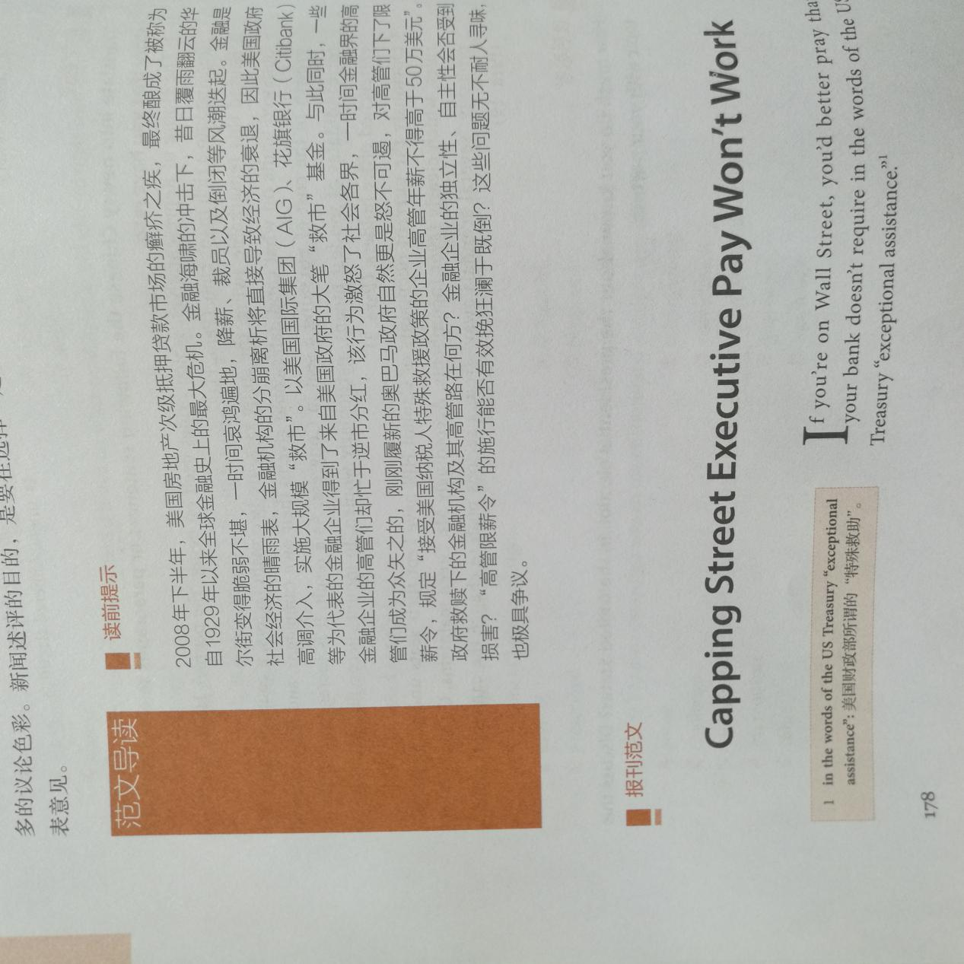
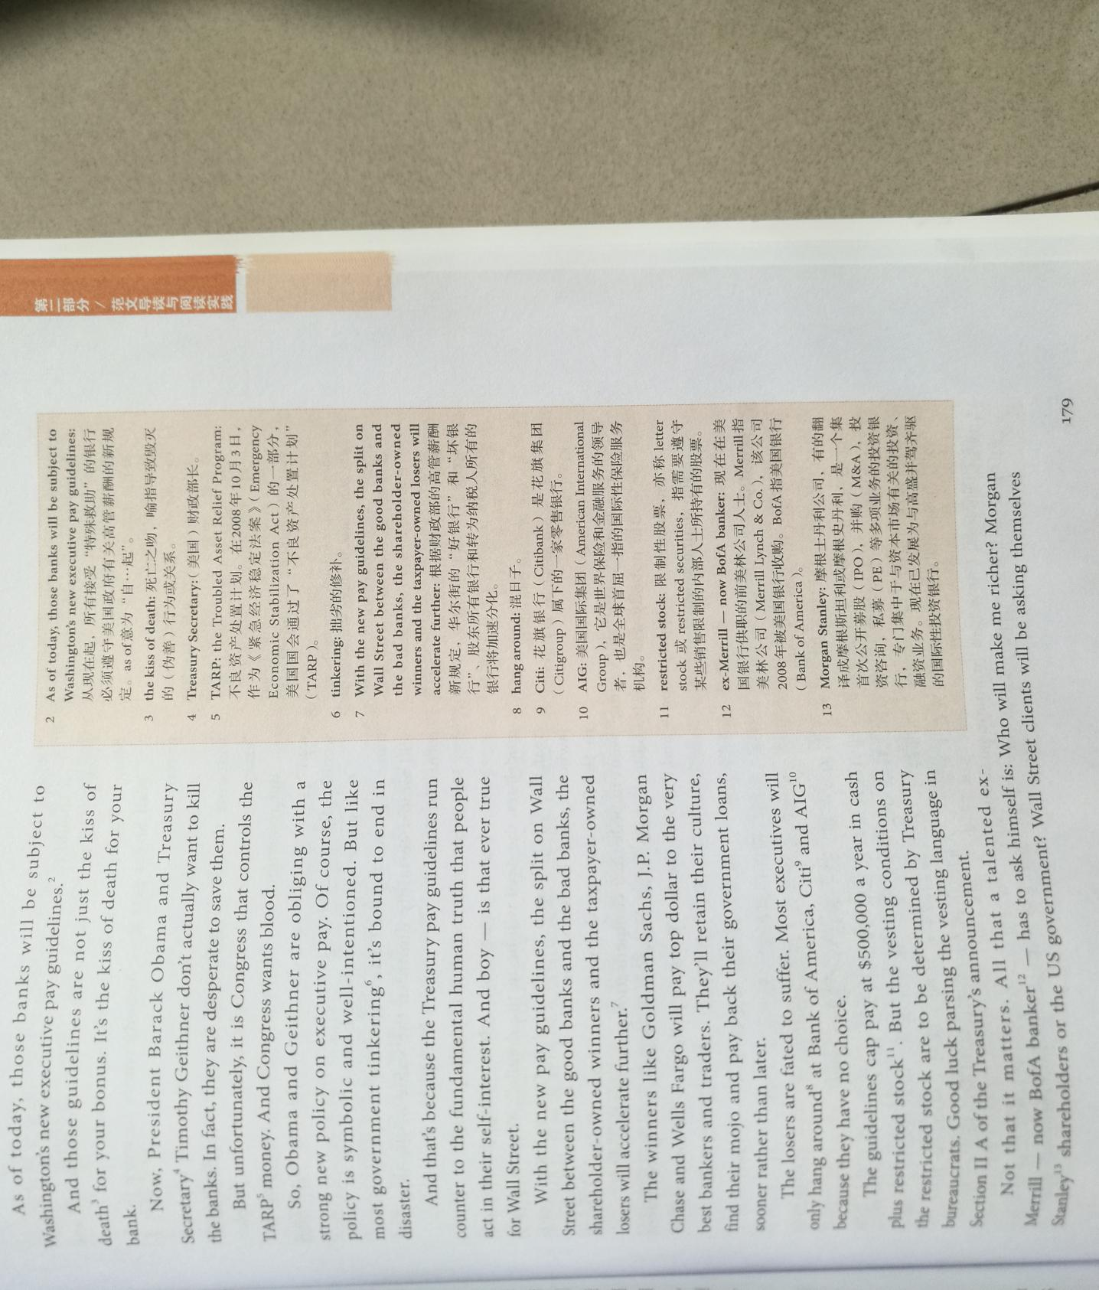

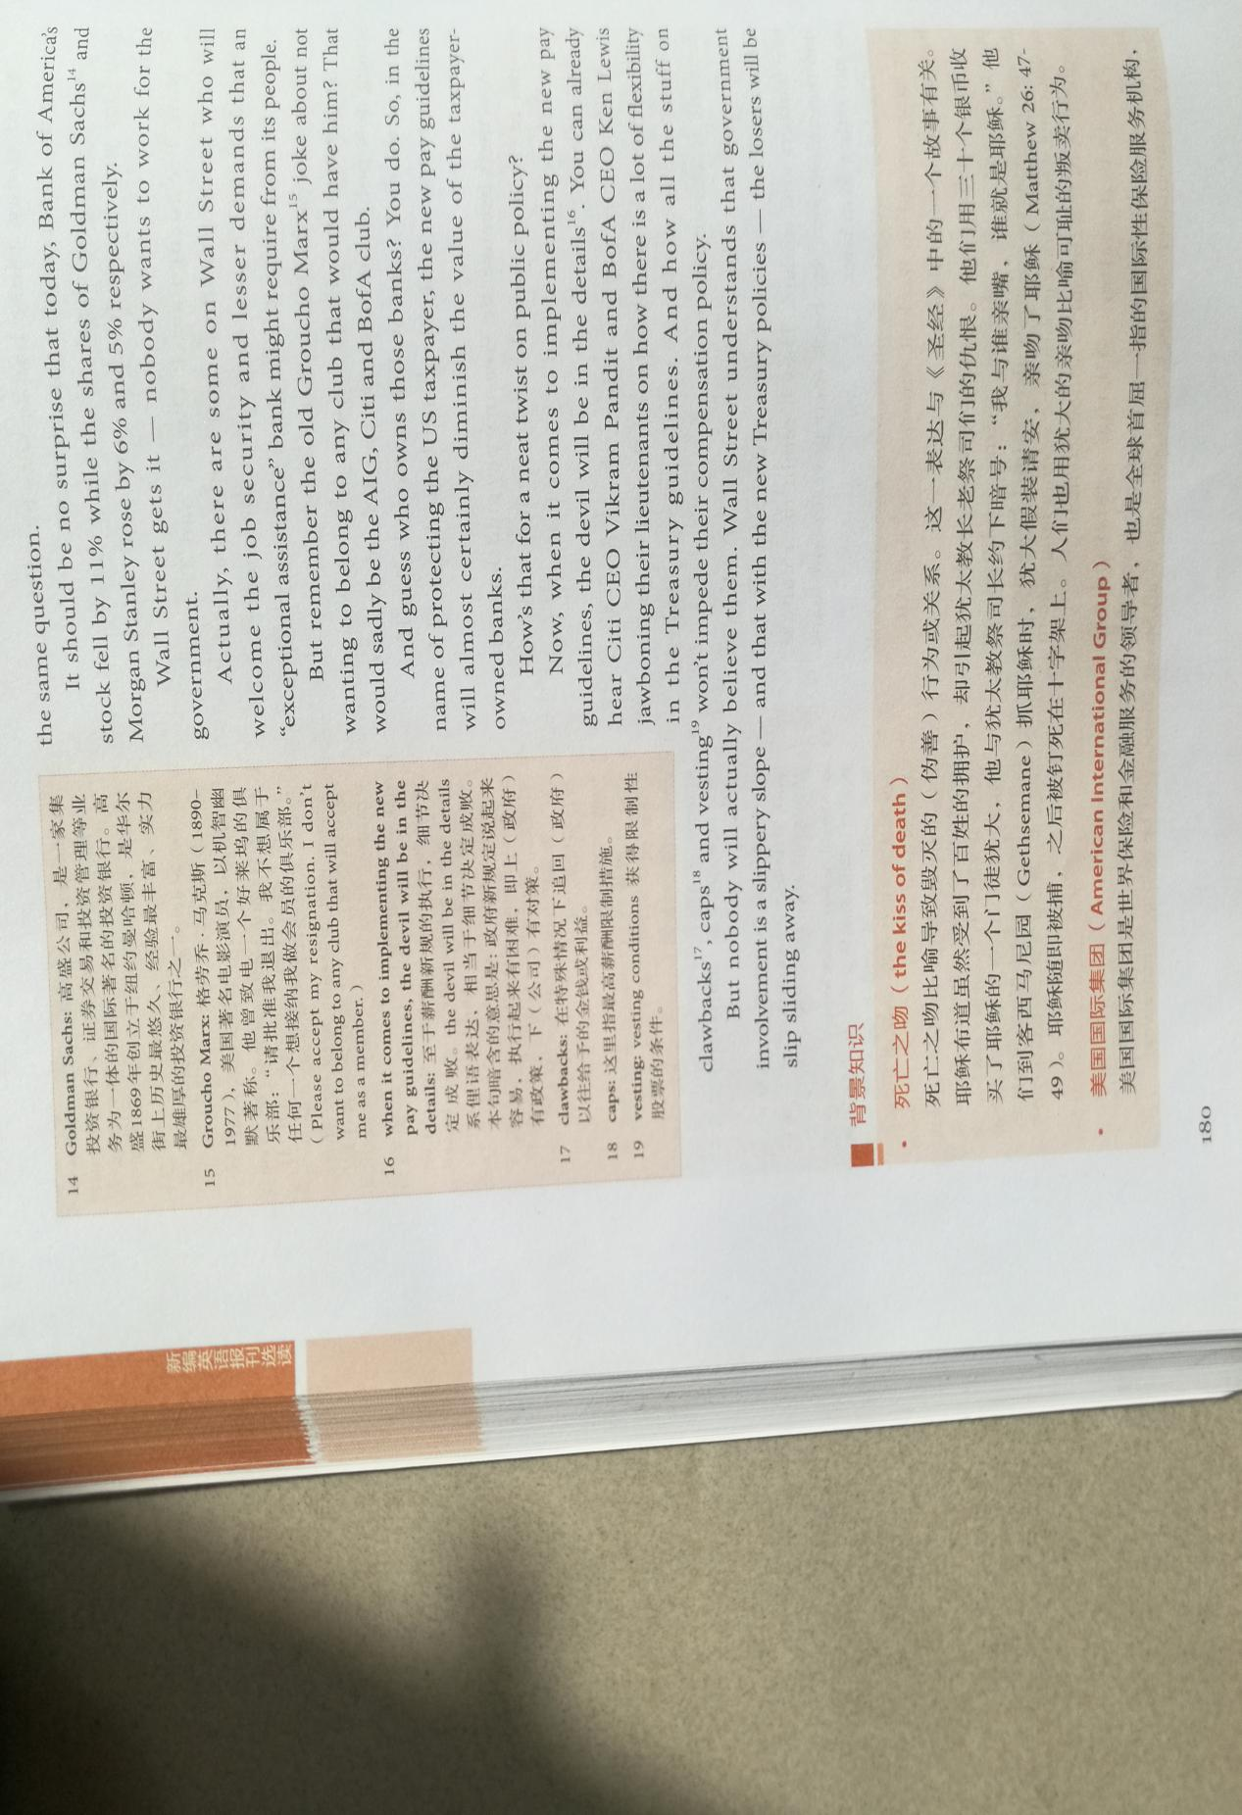

The second article
